HAIP
Healthcare Analytics & Intelligence Platform
Week 2 — Detailed Technical Report
Connected architecture · prediction · honest evaluation · tooling decisions

1. Executive Summary
In one line: Week 2 turned a pile of disconnected files into a single connected platform that can analyse, predict, and accept new hospital data — evaluated honestly.
This report explains every major step in plain language first, then in technical depth. It walks through how the database JOINs work, how each metric is calculated and why it was chosen, compares the tools and algorithms considered, and explains the reasoning behind using Synthea and building the upload feature. The goal is for this document to be more readable and understandable than the code itself.

2. The Big Picture: Before and After
Plain idea: we replaced six unrelated spreadsheets with one connected dataset where every record traces back to the same patient.

2.1 Where it started
The first plan used six separate datasets: admissions, billing, ICU, labs, medical documents, and patients. They came from different sources and shared no common identifier. That meant you could never ask a question that spanned two of them — for example, “do patients with this diagnosis cost more?” — because there was no way to link a diagnosis to a cost. The models also scored suspiciously high, which usually signals data leakage rather than genuine skill.

2.2 The decision to migrate
The fix was to switch to one connected dataset generated by Synthea (covered in detail in Section 6). Every record — a visit, a diagnosis, a lab result, a bill — carries the same patient_id, so they can all be joined together.
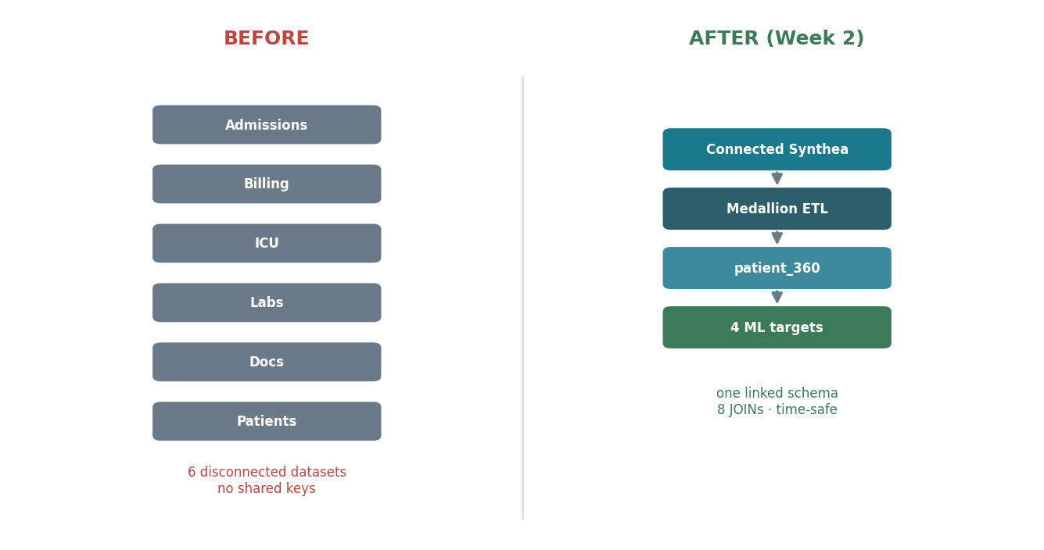
Figure 1 — Six disconnected datasets became one connected Synthea schema.

3. How the Database Works: The JOINs Explained
Plain idea: a JOIN is how the database stitches separate tables back into one complete picture of a patient, using a shared ID as the thread.

3.1 What a JOIN actually does
Imagine each table is a separate notebook. The patients notebook has names and ages. The encounters notebook has hospital visits. The conditions notebook has diagnoses. On their own, each is incomplete. A JOIN says: “for every visit in the encounters notebook, go find the matching patient in the patients notebook using the patient_id, and bring their details along.” Do this across all six tables and you reconstruct the full story of each patient.
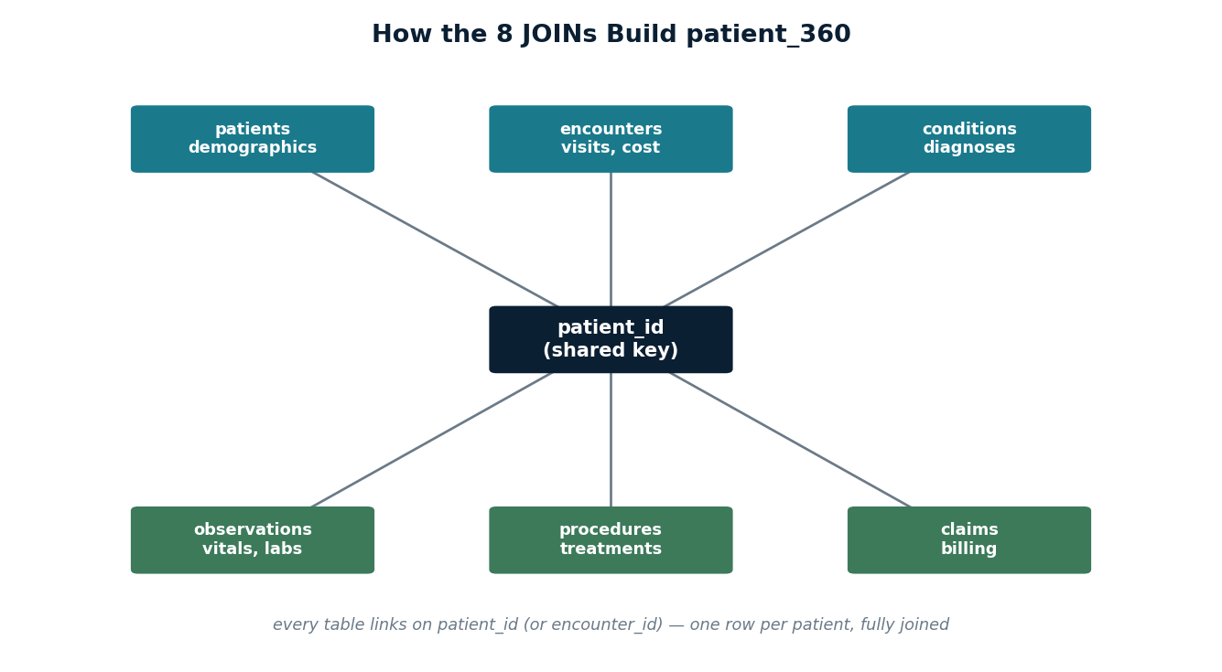
Figure 2 — All tables link on a shared key (patient_id / encounter_id) to build patient_360.

3.2 The technical detail
HAIP uses 8 JOINs to assemble its flagship view, patient_360. The pattern looks like this (simplified):
FROM encounters e
JOIN patients p ON p.id = e.patient -- demographics
JOIN conditions c ON c.patient = e.patient -- diagnoses
JOIN observations o ON o.encounter = e.id -- vitals/labs
There are two kinds of links used. An inner JOIN keeps only rows that match on both sides (used where the relationship must exist). A LEFT JOIN keeps every row on the left even if there is no match on the right (used for optional history, so a patient with no prior conditions still appears, with a zero instead of being dropped).

3.3 Why the time-ordering inside JOINs matters
A subtle but critical point: when joining a patient’s history, the SQL only counts events that happened BEFORE the current hospital stay (for example, prior_conditions_count uses conditions where the condition’s start date is on or before the stay’s start). This prevents the model from “seeing the future,” which is the leakage problem that inflated the old scores. The JOINs are written so that time always flows forward.

4. The Overall Data Flow
Plain idea: data moves through three cleaning stages, then feeds three engines — like raw ingredients becoming a prepared meal served three ways.
All data passes through a medallion architecture, a layered design with three tiers:
- Bronze — raw Synthea output loaded as-is. Nothing is changed; this is the untouched source of truth.
- Silver — cleaned and typed. Dates become real dates, text is standardised, and the 8 JOINs link the tables. This is the trustworthy working layer.
- Gold — business-ready views. patient_360 and the analytics aggregations live here. The dashboards and models only ever read from gold.
Three engines sit on top of gold: the analytics engine (SQL + Plotly charts), the ML engine (four risk models), and the forecast engine (Holt-Winters). They compute nothing from raw data themselves — separation of concerns keeps each layer simple and testable.
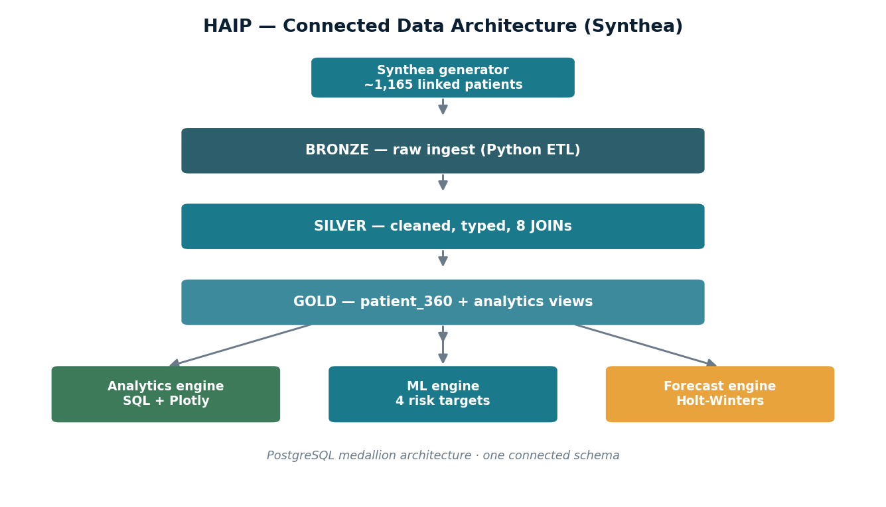
Figure 3 — Medallion data flow feeding the three intelligence engines.

5. Metrics: How They Work and Why We Chose Them
Plain idea: when the thing you’re predicting is rare, ordinary accuracy lies to you. We use metrics that can’t be fooled by rarity.

5.1 Why accuracy fails here
Risk events are rare. Mortality occurs in only ~32 of 1,100 encounters (about 3%). A lazy model that always predicts “no death” would be right 97% of the time — and would be completely useless, because it never identifies a single at-risk patient. This is why accuracy is the wrong tool, and it drives every other choice in this section.

5.2 Precision and Recall — the building blocks
Two ideas underpin everything:
- Precision answers: of all the patients the model flagged as high-risk, how many truly were? High precision means few false alarms.
- Recall answers: of all the patients who truly were high-risk, how many did the model catch? High recall means few missed cases.
There is always a trade-off. Flag everyone and recall is perfect but precision is terrible. Flag no one and precision is undefined while recall is zero. Good models balance the two.

5.3 PR-AUC — the primary metric
PR-AUC is the area under the Precision-Recall curve. It measures how well the model balances precision and recall across every possible decision threshold, focusing entirely on the rare positive class — exactly the at-risk patient we care about. A model that ignores positives scores a low PR-AUC, so it cannot hide behind the abundance of healthy patients.

Why PR-AUC over ROC-AUC
ROC-AUC is the more famous metric, but on heavily imbalanced data it is misleadingly optimistic because it gives credit for correctly identifying the many easy negatives. PR-AUC does not. Crucially, PR-AUC has an honest baseline: its “random guess” floor equals the positive rate. So mortality’s random floor is ~0.03, and a score of 0.42 is genuinely well above chance — weak in absolute terms, but real, and disclosed rather than hidden.
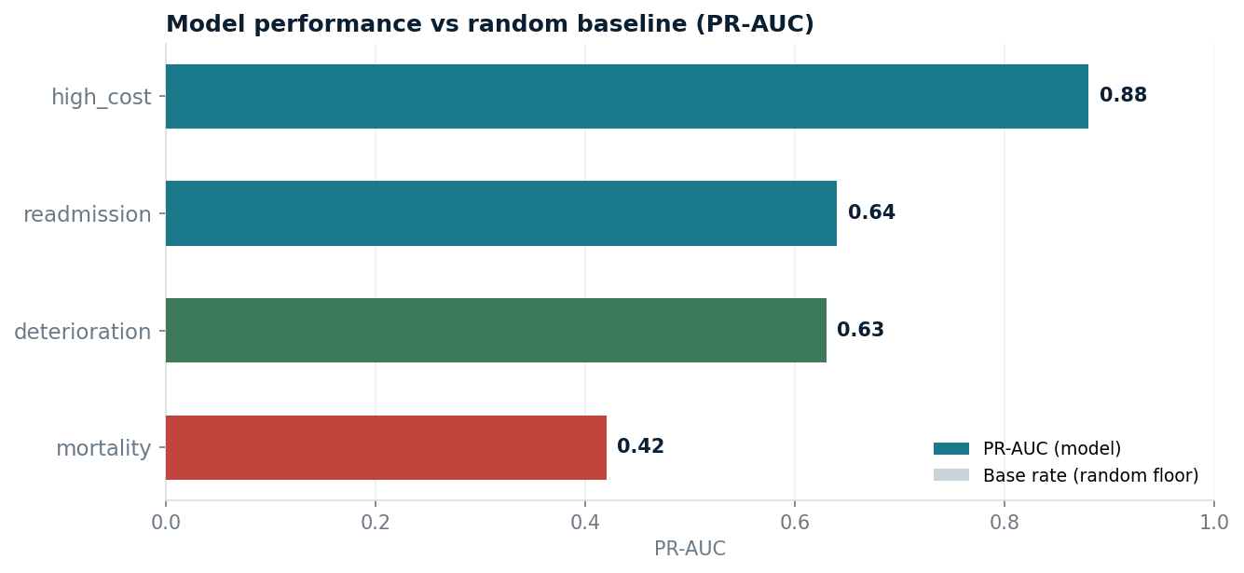
Figure 4 — Each target’s PR-AUC. Mortality (red) is weak and openly flagged.
Target | PR-AUC | Base rate | Read
high_cost | 0.88 | ~0.25 | Strong
readmission | 0.64 | ~0.18 | Decent
deterioration | 0.63 | ~0.22 | Decent
mortality | 0.42 | ~0.03 | Weak, disclosed

5.4 The confusion matrix
Every metric above is derived from four raw counts, shown in the confusion matrix. It compares what the model predicted against what actually happened:
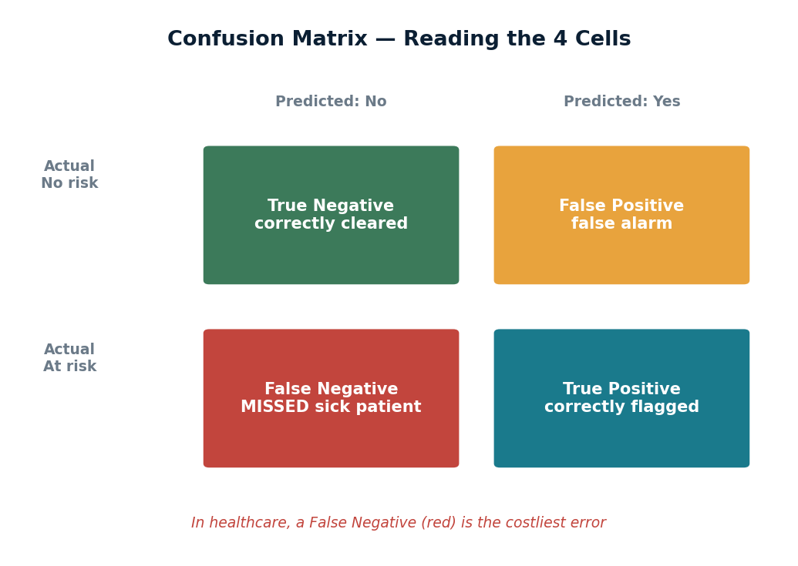
Figure 5 — The four cells of a confusion matrix. In healthcare the False Negative is the costliest error.
In a clinical setting the four cells are not equal in cost. A False Negative — telling a genuinely at-risk patient they are fine — is far more dangerous than a False Positive (a false alarm that leads to a precautionary check). The confusion matrix makes this visible so the trade-off can be discussed openly.

5.5 Cross-validation with variance
A single train/test split can be lucky. 5-fold cross-validation splits the data five ways, trains five times, and reports the average score plus the standard deviation (mean ± std). The standard deviation is the honesty signal: a small spread means the score is stable and trustworthy; a large spread means it swings with the data and should be treated with caution.

6. Why Synthea? (The Dataset Decision)
Plain idea: Synthea gives realistic, fully-connected patient data with none of the privacy or linkage problems of real records.
Synthea is an open-source synthetic patient generator. Choosing it solved several problems at once:
- Connected by design — every record for a patient shares the same ID, making the 8 JOINs possible. Real-world datasets are often fragmented; Synthea is linked out of the box.
- No privacy risk — the patients are synthetic, so there is no HIPAA/consent barrier. This is also why it can safely be sent to cloud LLM APIs later (real datasets like MIMIC cannot).
- Realistic structure — it mirrors true clinical record shapes (encounters, conditions, observations, claims), so the skills and code transfer to real systems.
- Reproducible — anyone can regenerate the exact dataset, which makes the whole project auditable.
- Free and unlimited — no licensing cost; capped here only by the laptop’s ~7.4GB RAM (~2,000 patients).
The trade-off, disclosed honestly: synthetic data does not capture every messy nuance of real patients, which is exactly why the project is framed as a proof-of-concept and a triage aid, not a diagnostic tool.

7. The Upload / Data Intake Feature
Plain idea: a second tab lets any hospital drop in its own file, check it, and get a dashboard — without touching the Synthea models.

7.1 What it does
The intake tab walks a user through: upload a file → the system auto-maps the file’s columns to the HAIP standard schema → it validates (are the required columns present and clean?) → it builds an analytics dashboard and can train a model on that uploaded data.

7.2 Why it is needed
It turns HAIP from a fixed demo into a platform. The Synthea tab proves the analytics on known data; the upload tab proves the platform can ingest new, unseen hospital data. That is a far stronger story for a real product.

7.3 The honest design choice
Critically, an uploaded file does NOT run through the trained Synthea models. Those models expect 19 specific Synthea features that a hospital file will never have. Instead, the upload tool trains a fresh model on the uploaded data’s own columns. Forcing incompatible data through the Synthea models would be dishonest ML; training a new model is the correct, transparent approach. Charts that need a column the file lacks are simply skipped — nothing is invented.

8. Tool & Algorithm Comparisons
Plain idea: every tool was a deliberate choice with a runner-up that was rejected for a specific reason.

8.1 Why these tools
Layer | Tool chosen | Alternative & why not
Database | PostgreSQL | SQLite — no concurrent/server features; weaker SQL
ETL | Python + Pandas | Spark — overkill for ~1,165 patients, heavy RAM
Dashboard | Plotly Dash | Streamlit — less control over multi-tab layout & callbacks
Charts | Plotly | Matplotlib — static, less interactive for a web app
Models | scikit-learn | Keras/PyTorch — unnecessary for tabular, small data
Forecast | Holt-Winters | ARIMA — similar, but HW handles seasonality simply

8.2 Why Random Forest for the models
Random Forest was chosen over the alternatives for tabular, small-to-medium data:
Algorithm considered | Why / why not | Decision
Logistic Regression | Simple, interpretable, but weak on non-linear feature interactions | Baseline only
Random Forest | Handles mixed numeric/binary, non-linear, robust to scaling, gives feature importance | CHOSEN
XGBoost | Often top accuracy, but heavier to tune and memory-hungry on a 7.4GB laptop | Deferred
Neural network | Needs far more data than ~1,100 rows; overkill, opaque | Rejected

Random Forest builds many decision trees on random subsets of the data and averages them. This makes it robust, hard to overfit, indifferent to feature scaling, and it naturally produces feature-importance scores — all valuable for a clinical context where you must explain why a patient was flagged.

9. Why the Script Changes Were Needed
Plain idea: each change fixed a real problem and made the whole project more honest, faster, or more usable.
Change | Why it was needed | Effect on the project
Connected Synthea + 8 JOINs | Old data couldn’t be linked | Real cross-table analysis; patient_360
Medallion ETL | Transforms were ad-hoc | Layered, auditable, reproducible pipeline
Added deterioration target | Only 3 risks covered | Broader early-warning; 4-risk panel
Switched to PR-AUC + CV | Accuracy hid weak models | Honest, defensible evaluation
Time-leakage guards | Scores were inflated | Metrics now reflect real predictability
Merged dashboards | Two apps were clumsy | One coherent product
Upload/intake tool | Demo was fixed to one dataset | Platform accepts new hospital data
Feature caching | Rebuild took ~13s repeatedly | ~13s → ~1ms; snappy dashboard
Clinical restyle | Default look was rough | Professional, presentation-ready UI

10. Honest-Engineering Principles
- No inflated metrics — PR-AUC over ROC-AUC for imbalance.
- Weak targets disclosed, not hidden (mortality, 0.42).
- Strict time-leakage vigilance in every feature and JOIN.
- Uploaded data trains its own model — no dishonest reuse.
- Framed as a proof-of-concept on synthetic data — a triage aid, not a diagnosis.

11. Next Steps
Week 3 begins the RAG phase: turning medical guideline documents into embeddings, building a vector index, and integrating an LLM assistant so users can ask questions over clinical guidelines. Week 4 adds an API layer, finalises the application, and Dockerises it for deployment.

